R² vs Adjusted R² - Formula-Based Explanation
(MPG Prediction)
(Self Understanding Material)

1. R² (Coefficient of Determination)
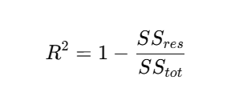
where,
- 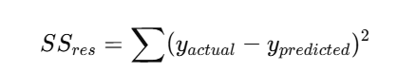This represents how wrong the model predictions
- 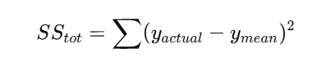This represents total variation in the data.
Meaning:
- R² tells how much better the model is compared to predicting the average MPG.
Limitation:
- R² always increases when new features are added, even if they are useless.
Why R² increases when you add more features (CRITICAL)?
When you add a new feature:
- Model becomes more flexible
- SS_{res} never increases, it only:
  - Decreases, (or)
  - stays the same. So…
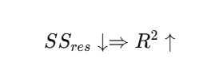
❗ Even if the feature is useless
This is the core weakness of R².

2. Adjusted R²
Formula:
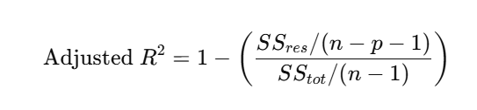
n = number of observations(cars)
p = number of predictors(HP,SP,VOL,WT)
So Adjusted R² asks:
“Did this new feature reduce error enough to justify its existence?”
Why can Adjusted R² can DECREASE?
If you add a useless feature:
- SS_{res}​ decreases slightly
- But penalty term (n−p−1) increases
- Net result:
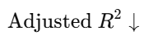
This is intentional and correct behavior.
And this what exactly you have seen in Coding with Example.

3. MPG Example
HP, WT → R² ↑, Adjusted R² ↑
HP, WT, Volume → R² ↑, Adjusted R² ↓
In case, if you add other features like… HP, WT, Volume, Car Color → R² ↑, Adjusted R² ↓

Final Takeaway:
- R² measures fit.
- Adjusted R² measures honest fit.

Best Interview Answer
“R² measures how well the model explains variance, but it always increases when input features are added.
Adjusted R² corrects this by penalizing unnecessary input features, making it a better metric for model comparison and feature selection.”

Remember!!!
Without Execution, Learning is Useless.

Regards,
AI Coach John

CEO & Founder of ProITbridge.
Youtube: https://www.youtube.com/@aicoachjohn
LinkedIN:https://www.linkedin.com/in/aicoachjohn/
Instagram: https://www.instagram.com/john_the_ai_coach/
Website: https://www.proitbridge.com/

